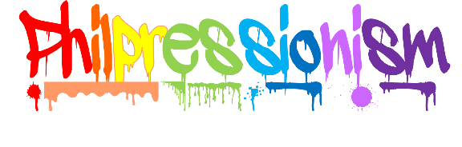

It’s More Art than Science.

PERMISSION REQUEST
(*Adults attending the retreat – Please fill out emergency section only.)

I hereby give my permission for my child, ___________________, to accompany the Dekko Foundation’s Youth Pod on a retreat to Kendallville, Indiana, on March 3 through March 6, 2022.

It is understood by me, in signing this request, that I acknowledge the following things to be true:

1. I have read all promotional materials regarding this retreat and fully understand the types of activities that my child will be involved in while at the retreat.

2. Reasonable supervision and adequate chaperones will be furnished, which will consist of Navigators, Guides, Dekko Foundation Staff members and parents.

3. Youth Pod members must arrive and depart the retreat with their Navigator. Individual students are not permitted to drive separately.

4. I hereby authorize the bearer of this Permission Request to act in my place and authorize emergency medical treatment for my child, ___________________________].

Parent/Legal Guardian Signature Parent/Legal Guardian Printed Name

Adult Witness Signature Adult Witness Printed Name

*In case of emergency during the retreat, please notify:

Name: Relationship:

Address:

Home Number: Cell Number: Work Number:

Doctor Name: Number: Address:

Dentist Name: Number: Address:

Please list any Allergies, Physical Limitations, Significant Medical Conditions, and Medications:

PLEASE ATTACH A COPY OF LATEST MEDICAL INSURANCE CARD

THIS FORM MUST ACCOMPANY THE YOUTH POD NAVIGATOR
ON THE ABOVE-MENTIONED RETREAT
Last Revised 2021

